Lab4: Advanced SELECT- SQL Commands:

### **Objectives**: Study multiple table query using Sub-Query and Join

**Estimated Time :** 3 hours

Lab Instruction

**Data Manipulation (DML) Commands**

DML consists of SELECT, INSERT, UPDATE, and DELETE commands. The last three commands are introduced in Lab2. Using the SELECT command to retrieve data from a table is explained in Lab3 as a basic query. This lab presents how to use the SELECT command to retrieve data from multiple tables in a database as an advanced query.

**Recall WORLD database in Lab3**

This is an ER diagram of WORLD - sample MySQL database - created in Dataedo. (<https://dataedo.com/samples/html2/World_MySQL/#/doc/m104/world-mysql-database-/modules/world-database-diagram>)

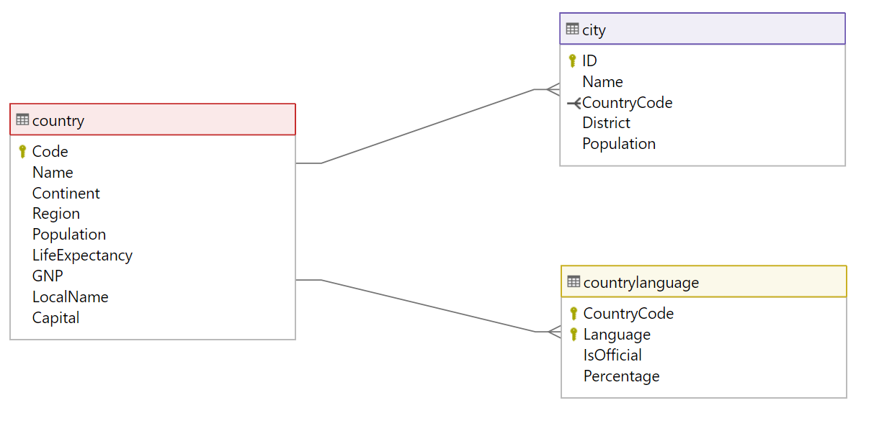

These are DB schemas created in Dataedo.

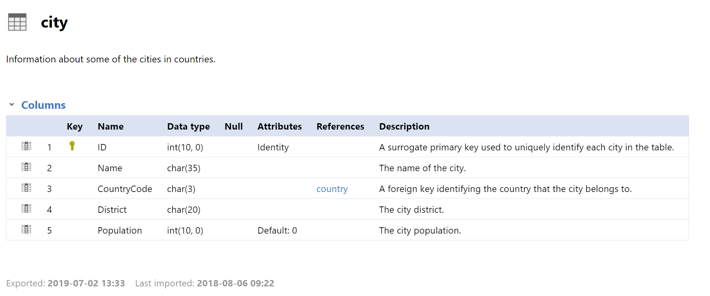

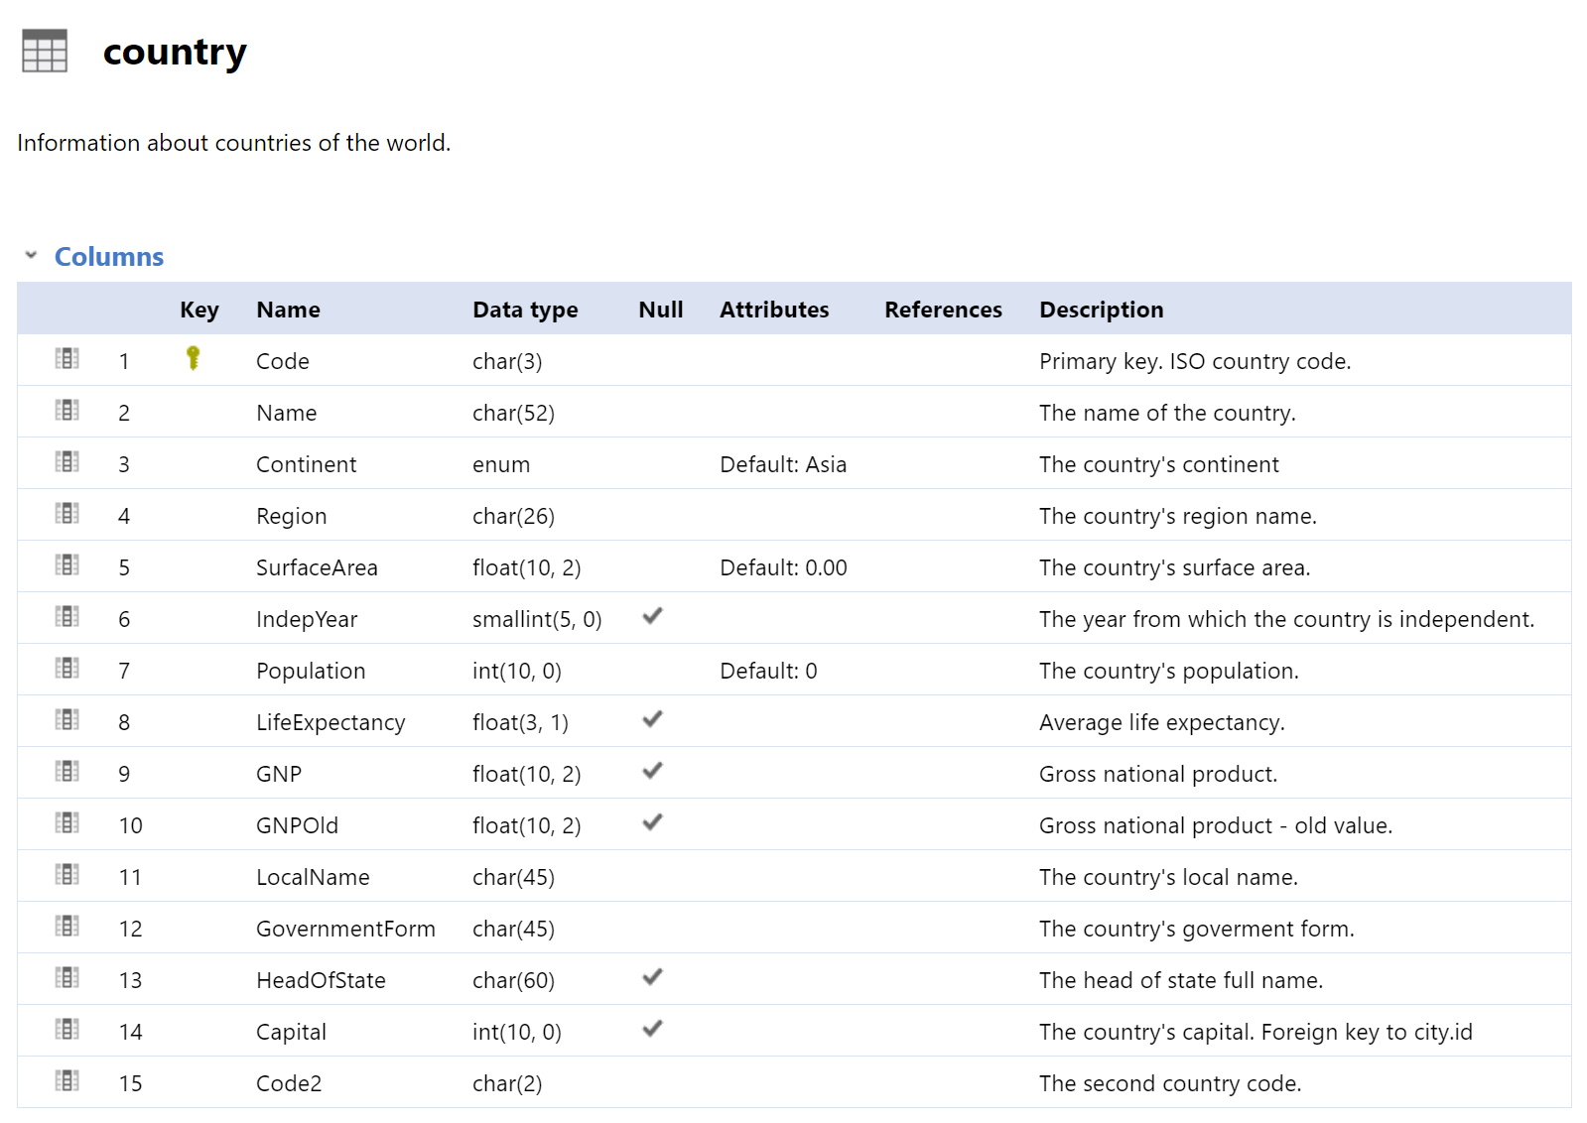

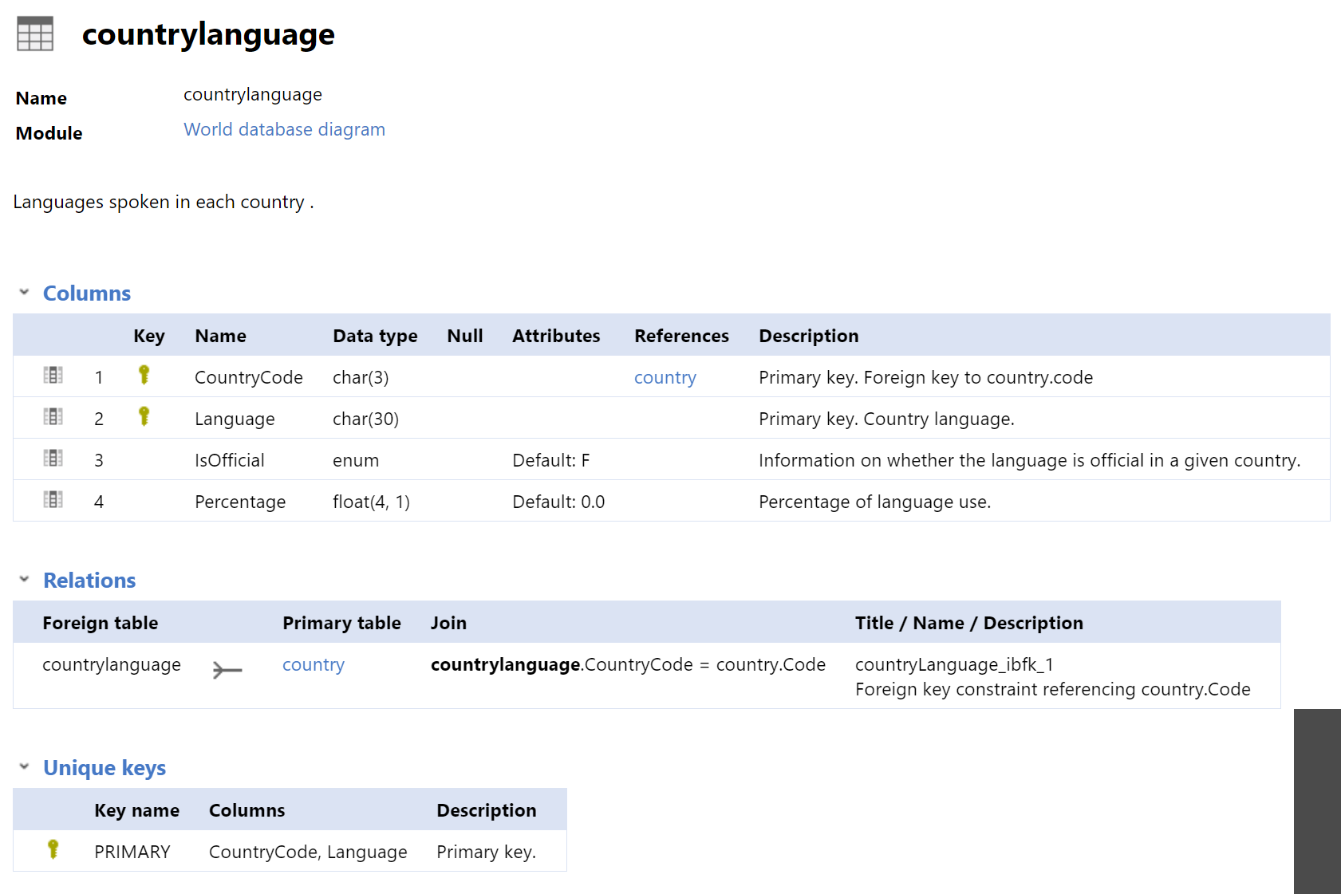

Write SELECT commands to query the following questions using the WORLD database.

1. List all languages spoken in Asian countries. (Using SubQuery)



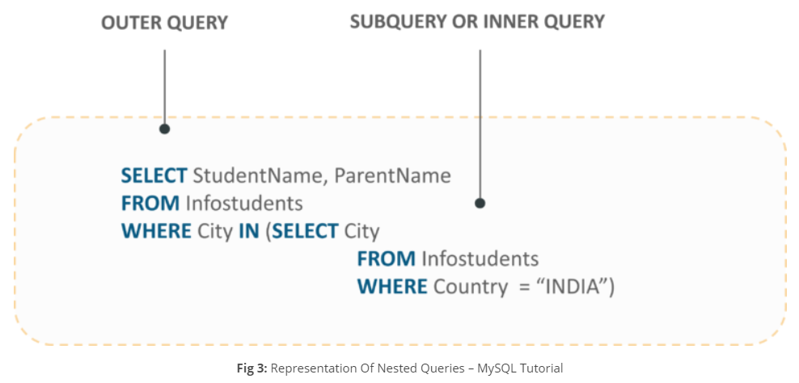

1. Find countries which are not in the countrylanguage table. (Using SubQuery, NOT IN)
2. List all languages spoken in Asian countries. (Using Join)

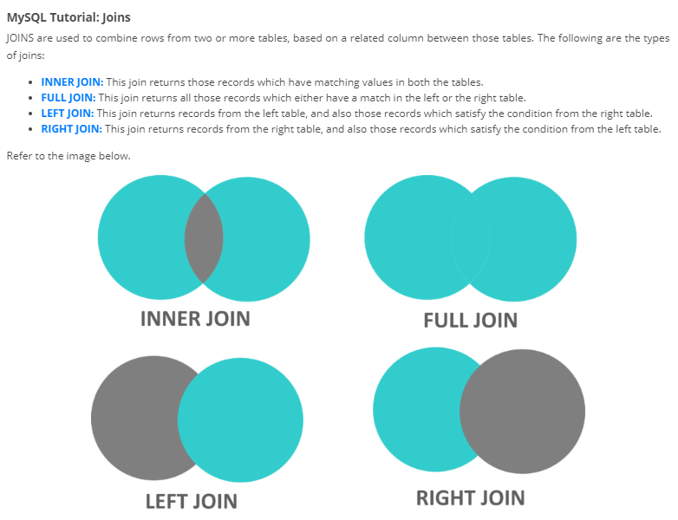

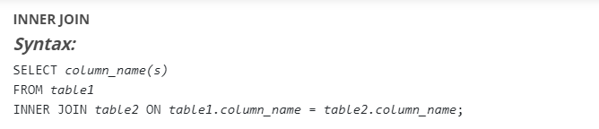

1. Find all official languages used in Asia (Using Join).
2. List all countries and their cities (if any, including also the countries that do not have cities).

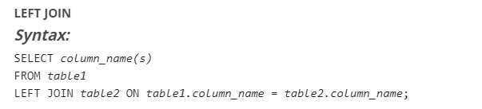

1. List all cities in the city table and their country (if any, including also the cities that do not have countries).

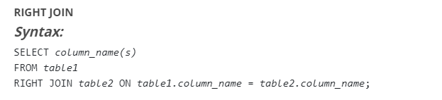

1. List all countries in Southeast Asia region those have life expectancy greater than the average of World LifeExpentancy? (Using SubQuery)
2. Is there any country in the WORLD database that has no language specified? Show your SQL to find the answer for this question. (Using Join)
3. What is the official language of Rio de Janeiro city? (Using Join)

Lab Submission

Submission System: Course LMS (primary),  
 Email: [dmmlab2020@gmail.com](mailto:dmmlab2020@gmail.com) (In case of you cannot submit in Course LMS)  
 For example; you want to submit LAB 4 and your id is st120200, your e-mail subject and your assignment filename must be LAB4_st120200

Total TASKS: 9